**( الرَّحِيمِ الرَّحْمَٰنِ اللَّهِ بِسْمِ )**

**MOBILE COMPTUING**

**Name : Umer Khan**

**Std Id : BSEF18A020**

**Git Hub:**



**GitHub, Inc.** is a provider of [Internet hosting](https://en.wikipedia.org/wiki/Internet_hosting_service) for [software development](https://en.wikipedia.org/wiki/Software_development) and [version control](https://en.wikipedia.org/wiki/Version_control) using [Git](https://en.wikipedia.org/wiki/Git" \o "Git). It offers the [distributed version control](https://en.wikipedia.org/wiki/Distributed_version_control) and [source code management](https://en.wikipedia.org/wiki/Source_code_management) (SCM) functionality of Git, plus its own features. It provides [access control](https://en.wikipedia.org/wiki/Access_control) and several collaboration features such as [bug tracking](https://en.wikipedia.org/wiki/Bug_tracking_system), [feature](https://en.wikipedia.org/wiki/Software_feature) requests, [task management](https://en.wikipedia.org/wiki/Task_management), [continuous integration](https://en.wikipedia.org/wiki/Continuous_integration) and [wikis](https://en.wikipedia.org/wiki/Wiki) for every project

Git Hub account **: umerk10**

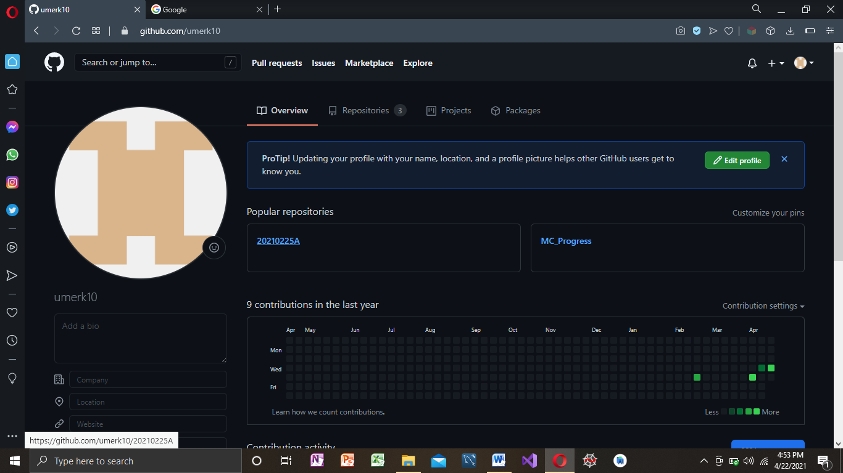

Repsitory Making : https://github.com/umerk10/20210225A.git

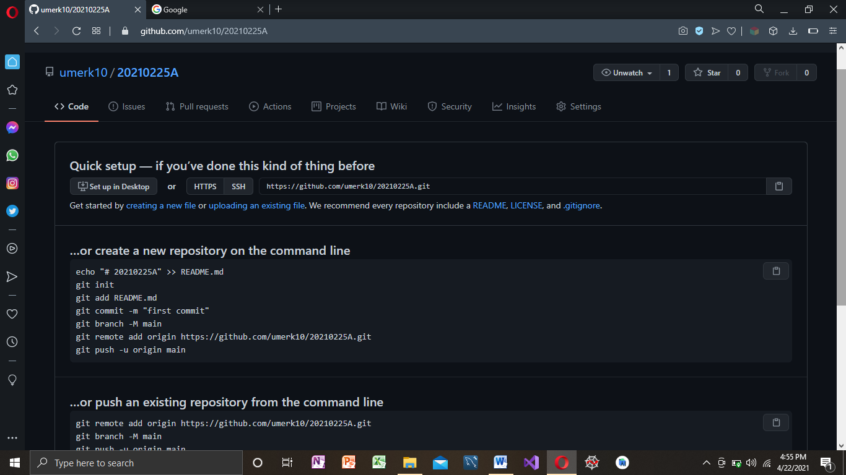

Git clone

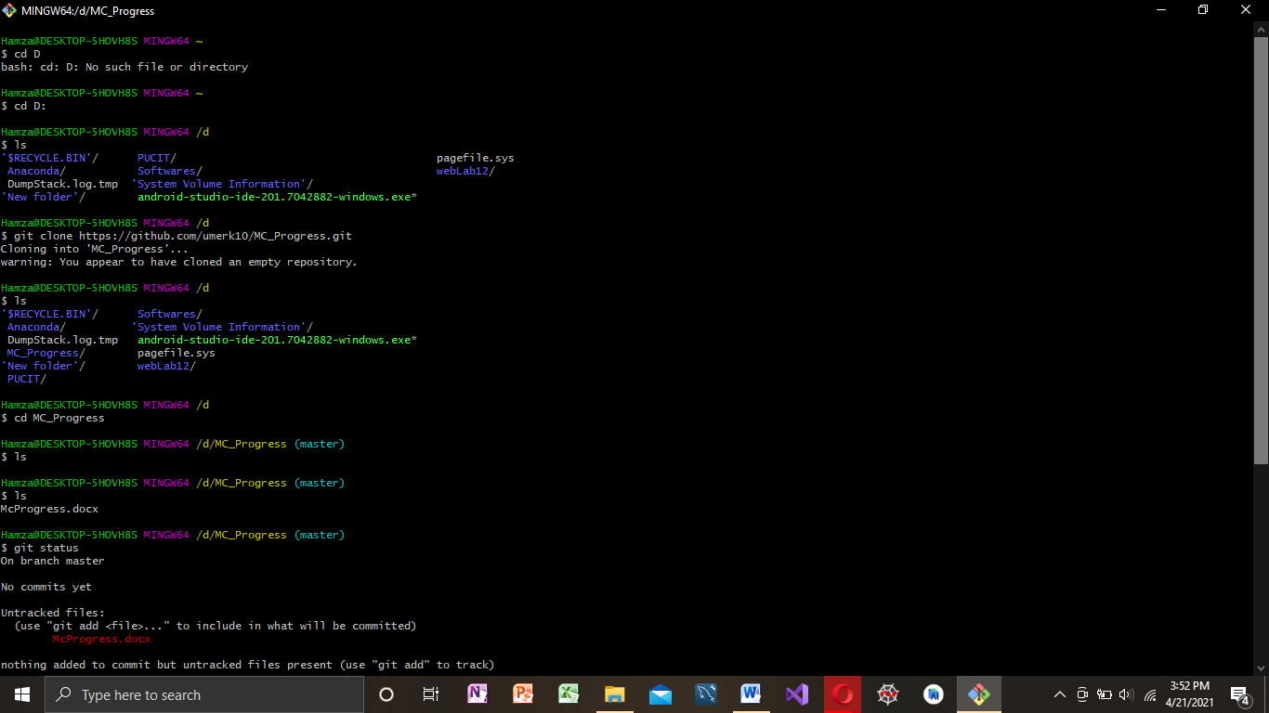

Git Add,Commit,Push,Status:

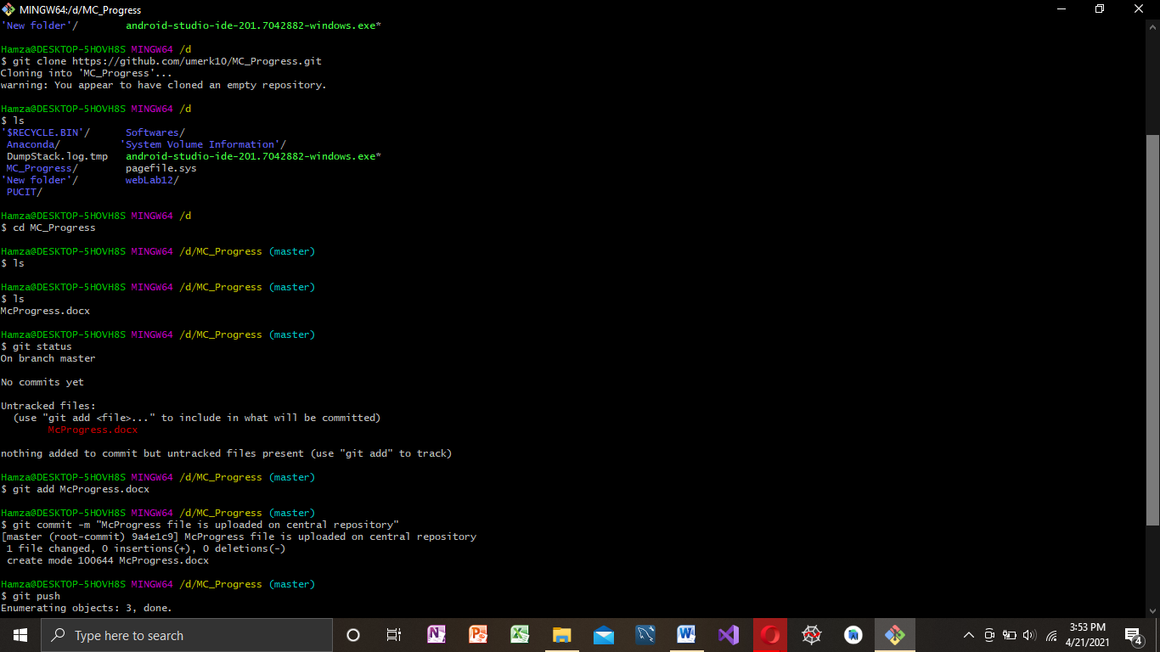

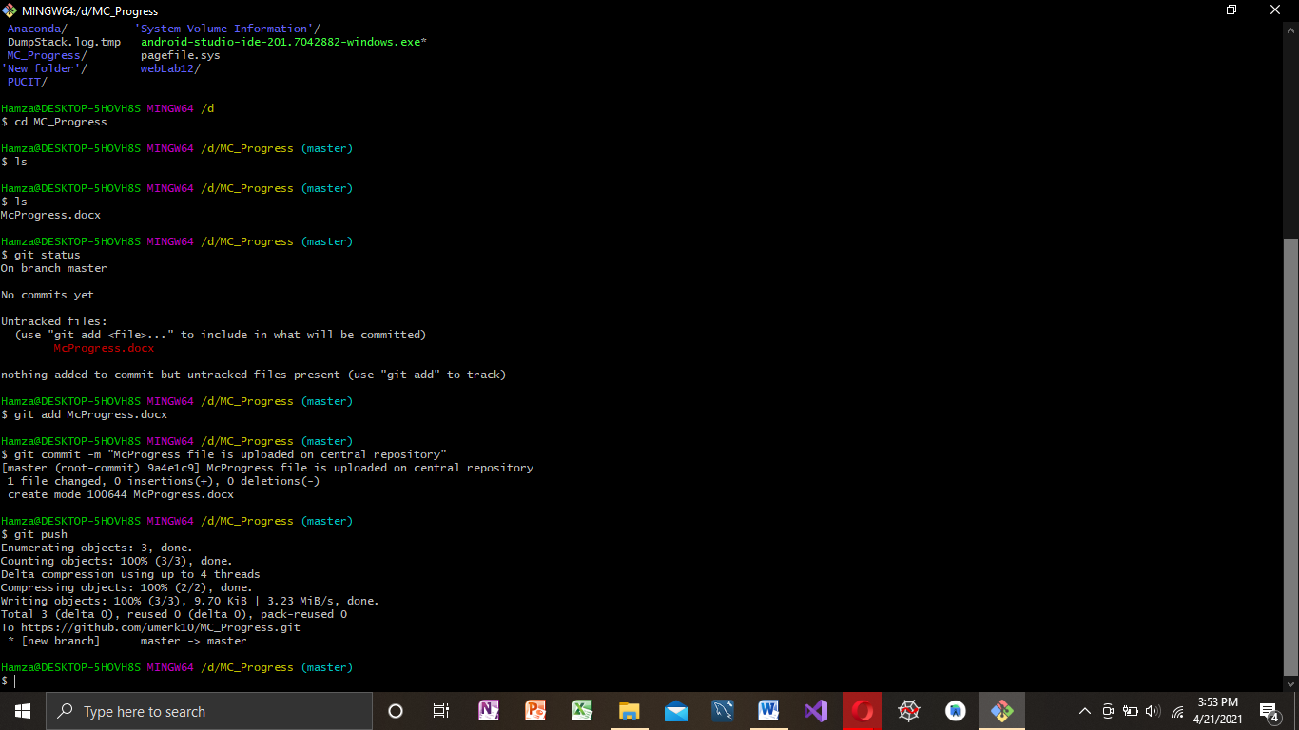

**Andriod Studio:**



**Android Studio** is the official[[7]](https://en.wikipedia.org/wiki/Android_Studio#cite_note-:0-7) [integrated development environment](https://en.wikipedia.org/wiki/Integrated_development_environment) (IDE) for [Google](https://en.wikipedia.org/wiki/Google)'s [Android](https://en.wikipedia.org/wiki/Android_(operating_system)) [operating system](https://en.wikipedia.org/wiki/Operating_system), built on [JetBrains](https://en.wikipedia.org/wiki/JetBrains" \o "JetBrains)' [IntelliJ IDEA](https://en.wikipedia.org/wiki/IntelliJ_IDEA" \o "IntelliJ IDEA) software and designed specifically for [Android development](https://en.wikipedia.org/wiki/Android_software_development).[[8]](https://en.wikipedia.org/wiki/Android_Studio#cite_note-8) It is available for download on [Windows](https://en.wikipedia.org/wiki/Windows), [macOS](https://en.wikipedia.org/wiki/MacOS" \o "MacOS) and [Linux](https://en.wikipedia.org/wiki/Linux) based operating systems or as a subscription-based service in 2020.[[9]](https://en.wikipedia.org/wiki/Android_Studio#cite_note-9)[[10]](https://en.wikipedia.org/wiki/Android_Studio#cite_note-10) It is a replacement for the [Eclipse Android Development Tools](https://en.wikipedia.org/wiki/Eclipse_(software)#Android_Development_Tools) (E-ADT) as the primary IDE for native Android application development.

Button:

A button consists of text or an icon (or both text and an icon) that communicates what action occurs when the user touches it.

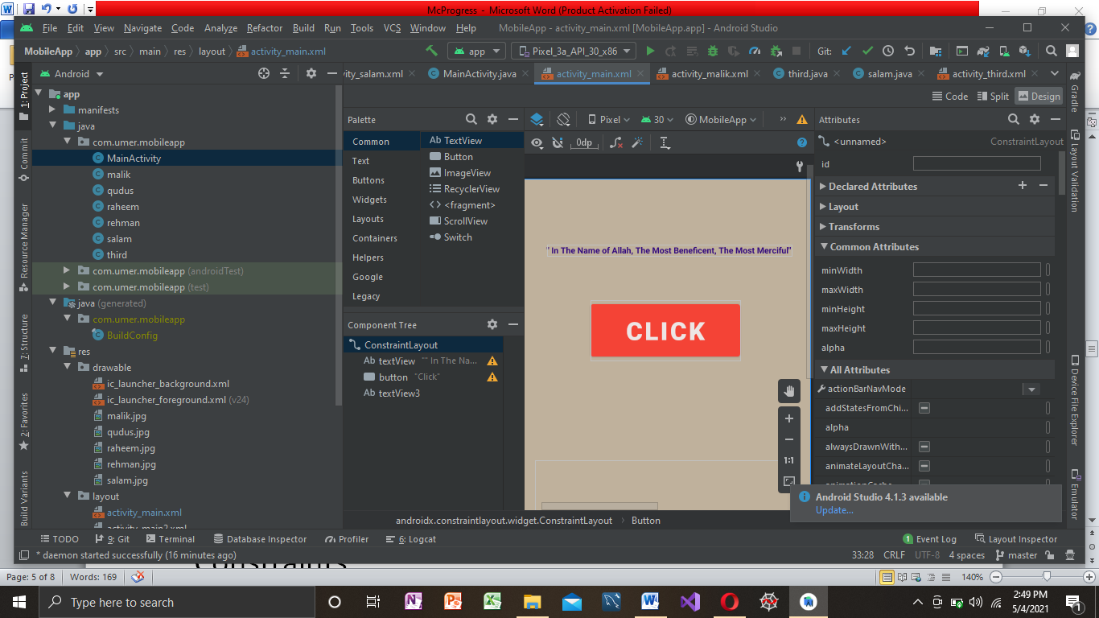

Constraints:

 A **constraint** represents a connection or alignment to another view, the parent layout, or an invisible guideline.

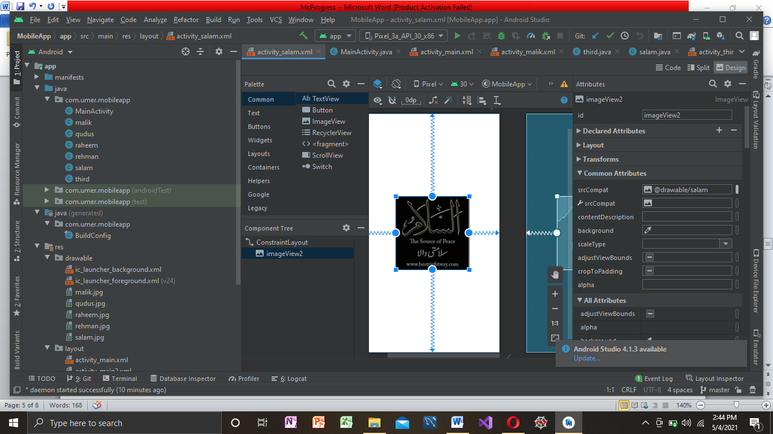

onClick Function:

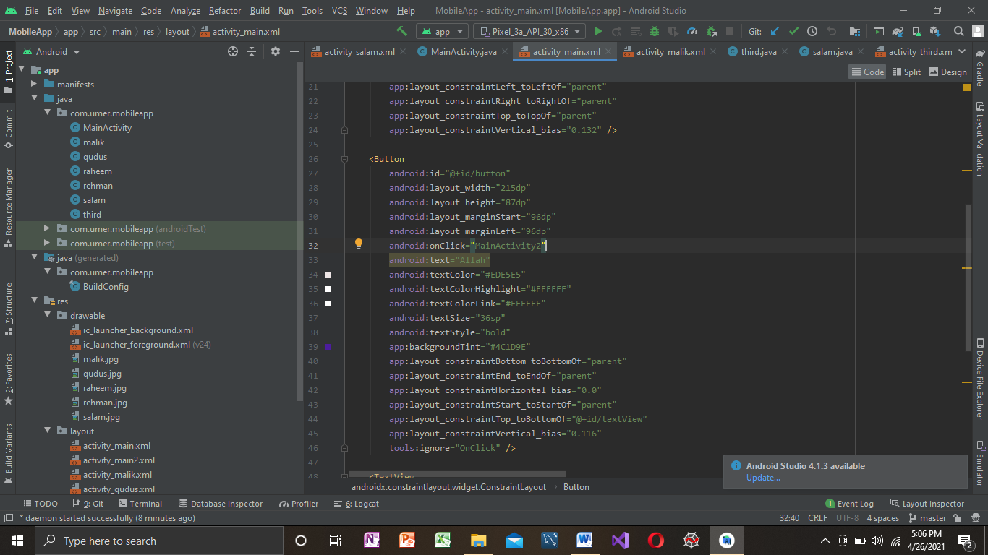

Intent:

**Android Intent** is the message that is passed between components such as activities, content providers, broadcast receivers, services etc. It is generally used with startActivity() method to invoke activity, broadcast receivers etc.

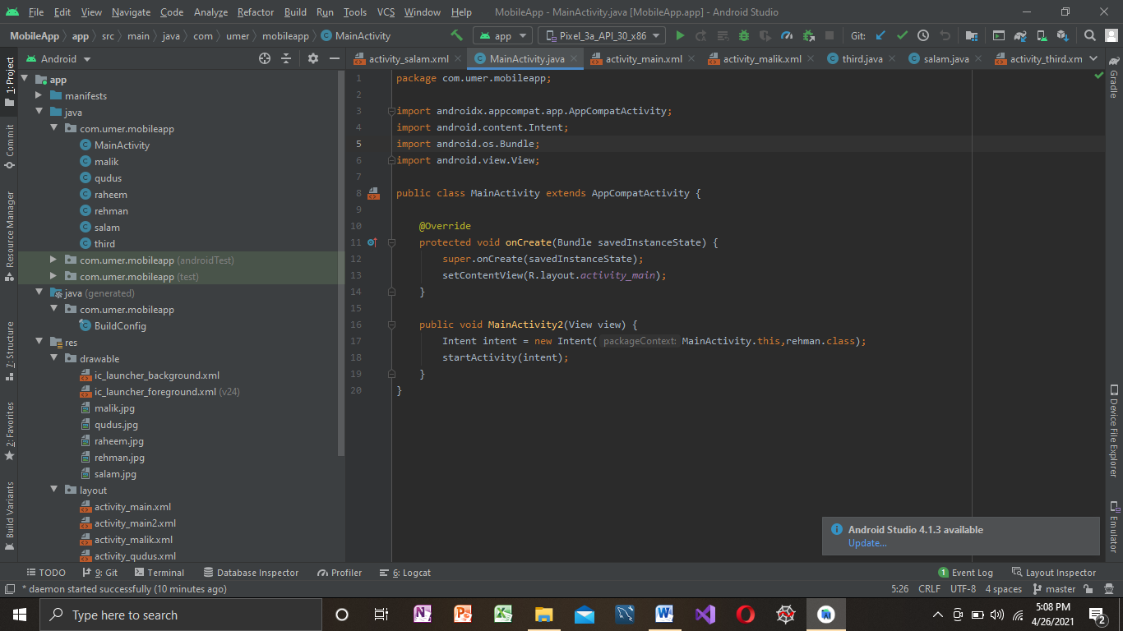

Animation:

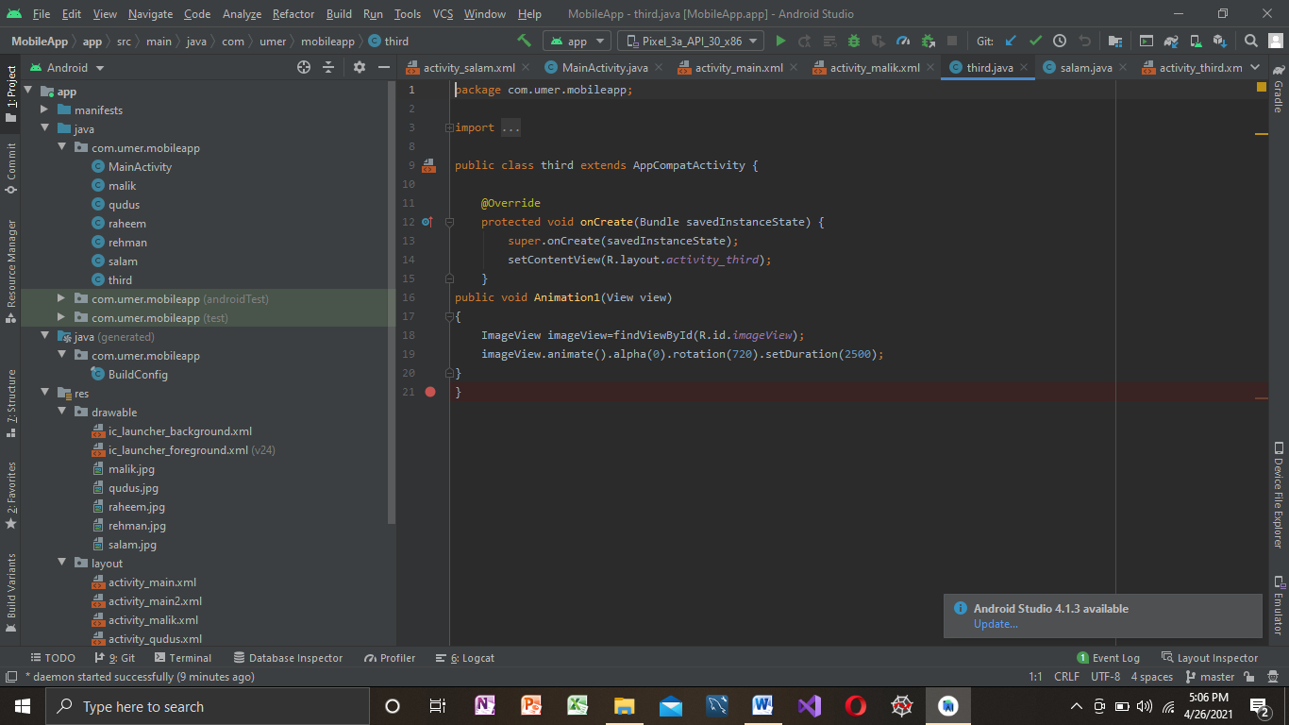

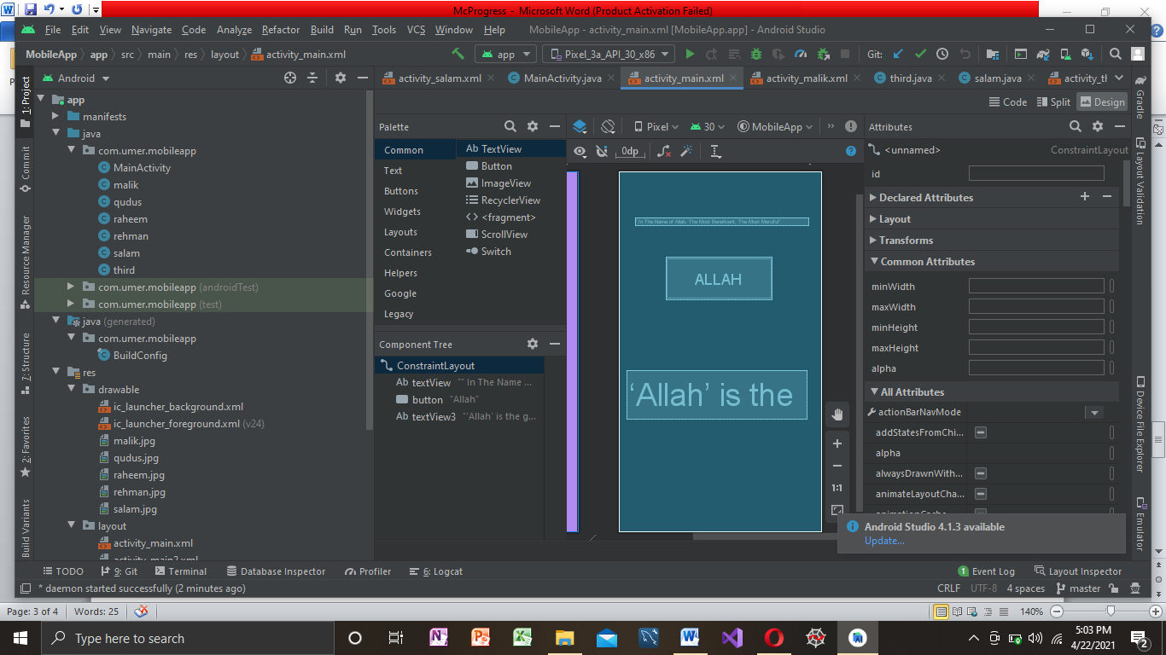

Basic Mobile Application:

 Video of basic app

Adapter:

Adapter is a bridge between UI component and data source that helps us to fill data in UI component. It holds the data and sends the data to an Adapter view then view can takes the data from the [adapter](https://abhiandroid.com/ui/adapter/) view and shows the data on different views like as list view

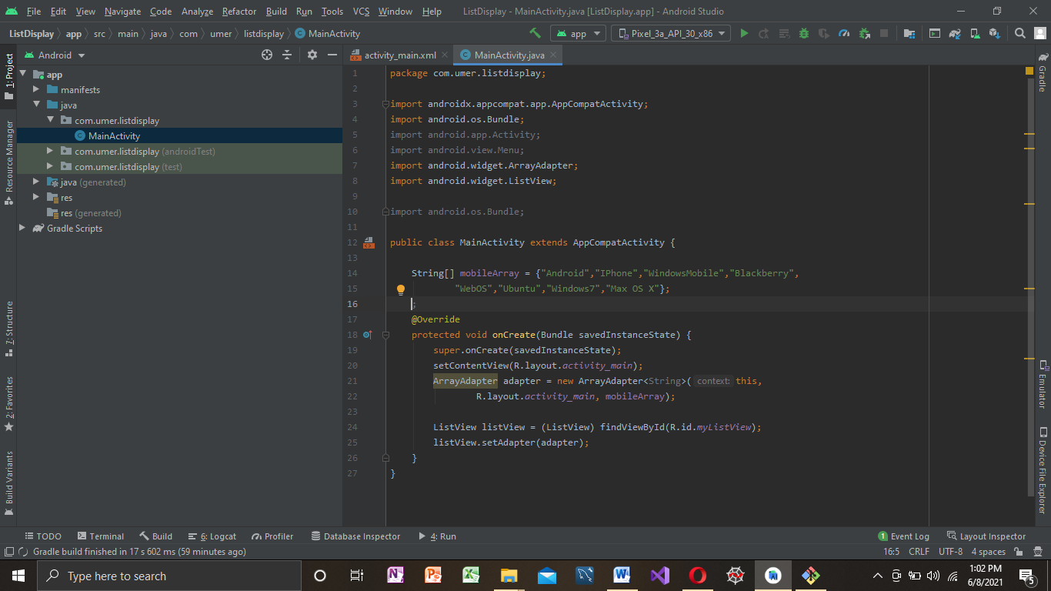

List View:

Android **ListView** is a view which groups several items and display them in vertical scrollable list. The list items are automatically inserted to the list using an **Adapter** that pulls content from a source such as an array or database. 